ARTH 345 Spring 2021
Institutional Affiliation
Professor’s Name
Student’s Name
Date
Test 3

Part 1: Three short answer questions
Question 1.
Explain what a militia company (or civic guard) is in a 17th-century Dutch city.
A militia is a cluster of prepared citizens who enter military service when an essential need has a long and quarrelsome past. IN THE 17TH Century Dutch, these City Guards were known as Schutterijj, and their role was to protect the medieval towns from attacks and revolts.

Questions 2 and 3 relate to this image.
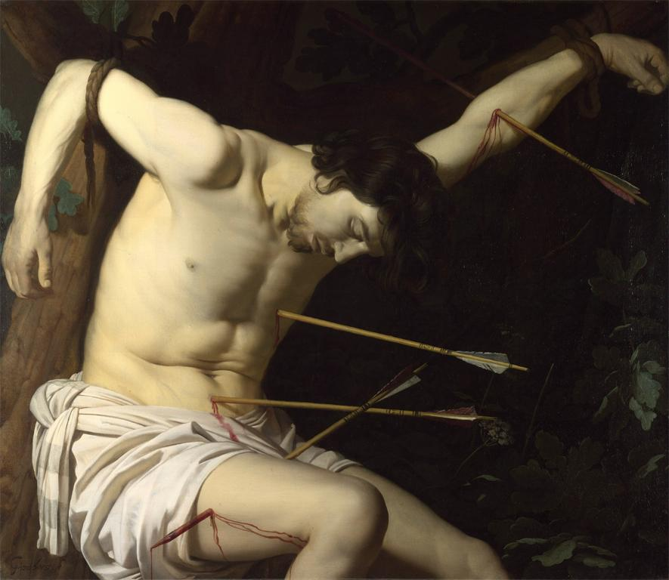
Gerrit van Henthorns, St. Sebastian, c. 1623

Question 2.
Gerrit van Henthorns is known as one of the “Caravaggisti,” i.e., an artist who adapted the style of Caravaggio—an Italian painter from the turn of the 17th century—in his art. Name two characteristics in this painting that would explain that label.
There was the existence of prominent figures in the paintings which dominated the forefront.
The painting had an exaggerated tonal contrast with dark glooms and bright climaxes.

Question 3.
The Dutch Republic’s official religion was Calvinism, which opposed the use of images of saints in worship. Why was Gerrit van Henthorns able to make this painting of St. Sebastian a Catholic subject?
St. Sebastian was a Roman centurion who changed his religion from ancient Dutch Calvinism to Christianity. Garret made this painting of a saint because it depicted what punishment one would receive if they turn against the Dutch religion.

Part 2: Three single-image essay questions
Question 1
Who was the group depicted in this painting? How did Rembrandt transform a distinctively Dutch form of portraiture in this painting?

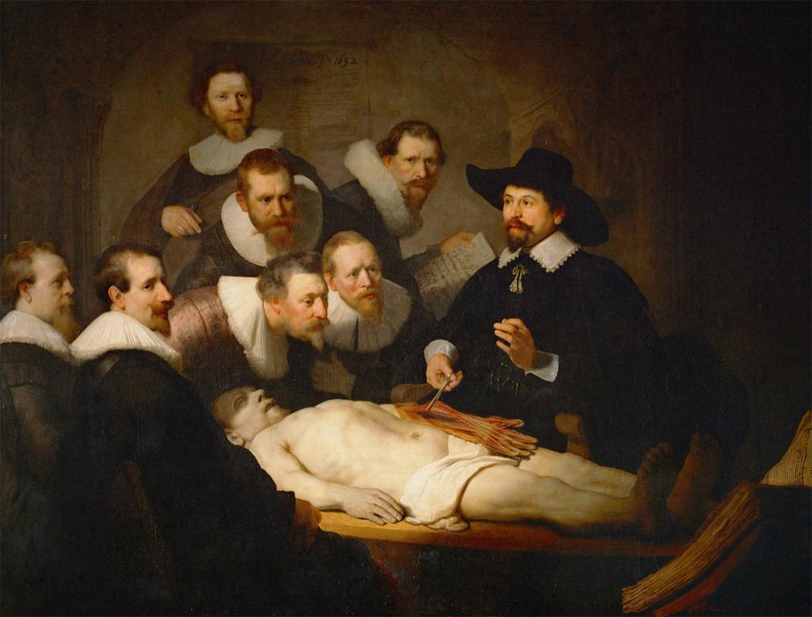
Rembrandt, Anatomy Lesson of Dr. Nicolaes Tulp, 1632.

This painting depicts a group of Amsterdam seven surgeons and one physician. The Rembrandt paintings were different as most of them were painted while looking in a mirror which means that his drawings reversed his actual features. He also ignored the usual anatomical conventions and also focused instead on the psychological aspects. In the Dutch portray, like one of the surgeons and the corpse were seen in the Centre, enclosed by societal members, and everyone would be painted gazing out of the painter's picture. Rembrandt was able to do the painting differently by adopting new approaches, which creates a mixture of collection description and action image. The painting is different at first, having the figures unified by token gestures and glances but still had the same composition. This kind of difference would make any client satisfied with the painting, making the Rembrandt painting distinctively from the Dutch.

Question 2
According to Ann Jensen Adams' essay you read for module 8, landscapes are not simply accurate views of reality but instead carry significance for the Dutch. Discuss how Ruisdael gives you a selective view of his hometown of Haarlem. What elements does he emphasize?

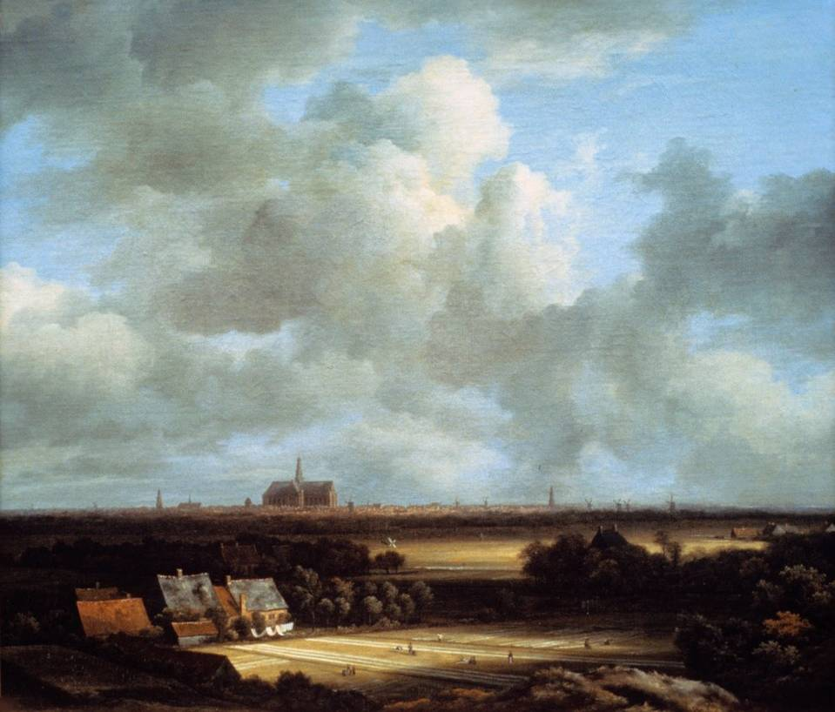

Jacob van Ruisdael, View of Haarlem, c. 1670

Ruisdael views of the Haarlem area compared with the linen-bleaching fields patent pride in the town. The name Haarlemer as suggested was issued to any linen washed-out around Haarlem or neighboring societies. These painted views were only depicted to the Haarlem washed out even though the trade existed somewhere else. The Ruisdael and Rembrandt's markets' imaginary uniqueness resulted from Haarlemer Bleek's international success, which later praised in the city past. The fields in Haarlem's view are considered to have an industrial subject that is filled with a business bleach. The flat, bright white strips seen of the linen are visible in the neighborhood of the town. He mainly emphasized the landscapes, museums, graphics.

Question 3
Explain the subject of the painting and where it was made. How did Eckhout portray the female figure, and what does it reveal about seventeenth-century Dutch attitudes towards this land's indigenous people?

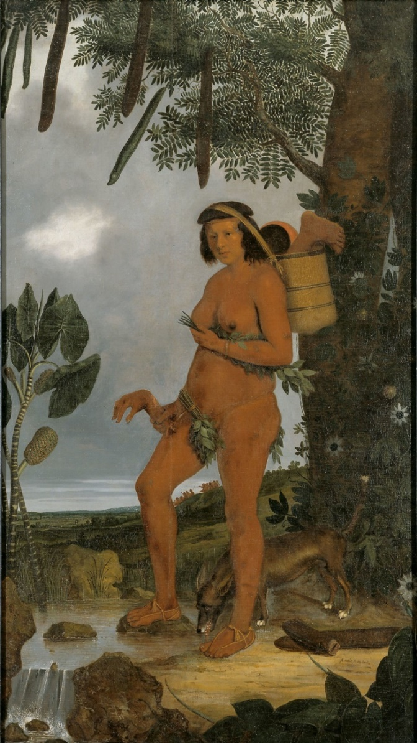

Albert Eckhout, Tapuia Woman, 1641
The main point of the tapuia woman's painting was to represent the automatic tribes of Brazilians whom the European regularly were engaged in a fight. The nakedness of the women saved with some leaves, strings, and miniature adornments marked them as uncivilized in colonialists' presence. The reference of eroticism to anthropophagy undermines women's nakedness. Tapia woman is seen carrying cut off limbs, a dog at her feet probably was described as living in distant regions of the globe. This painting was made in Dutch Brazil.
The Eckhout unruffled a Tapuia woman holding a cut-off human hand and leg in her basket, reflecting the Europeans label that native Americans trained cannibalism.
Dutch achieved so much due to their advantage of a satisfactory agricultural base. They achieved success in the fishing industry in the 16th century before engaging in a far-flung maritime empire in the 17th century. On the other hand, the indigenous Americans who were hunters added advantage to the French and Dutch colonizers who interacted with the native Americans through intermarriage and military alliances.

